Shannen Daly, Levi Hubbard, Sean Lantto

**Using Fuzzy Logic to Optimize an Oven**

MAE 565 – Spring 2016

Artificial Intelligence Techniques in Engineering

Department of Mechanical and Aerospace Engineering, West Virginia University, Morgantown, WV 26506/6106

03/29/2017

## Abstract

## Table of Contents

Abstract i

Table of Contents ii

Symbols iii

Introduction 1

Procedure 2

Technical Discussion 4

Results 5

Conclusions and Recommendations 5

References 6

## Symbols

Symbol

Aij

cij

nl

u*

Description

Area of MF trapezoid

Height of MF trapezoid

Number of rows/columns

Crisp output

Unit

## Introduction

Certain recipes require an oven to remain at or around a certain temperature to properly cook food to a desired quality. Keeping an oven at a particular temperature is a task that can be a little difficult to manage, but necessary. Typically, when cooking with an oven, the oven would be “set” to a certain temperature with a knob that it is trusted to heat up to. The user would usually trust the oven to go to the desired temperature, but if they really wanted to check, they would have to measure with a thermometer. This system could present problems from measurement error to the oven not heating up properly but remaining unchecked and thus, uncorrected.

A fuzzy logic system was used to improve upon these limitations. By taking measurements of the temperature within the oven and the temperature rate as inputs, the required voltage of the oven’s heating unit and internal fan may be acquired as outputs. This is done by going through the process as prescribed by any working fuzzy logic system and will be discussed in later sections of this report. These outputs are then used to maintain the oven’s inner temperature at the desired value.

## Procedure

The following block diagram shows the design of the fuzzy logic system.

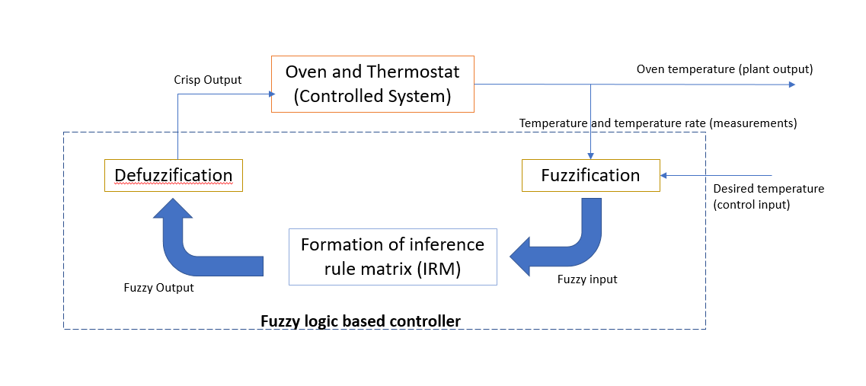

The system was initialized at an initial temperature of room conditions with a command of a desired temperature. The temperature rate will come from measuring the difference in the oven’s temperature from one step to the next. This will give the two inputs to the system: temperature and temperature rate. These two inputs were then split into a range of five linguistic values each so that they may be recorded as fuzzy sets. These values were scaled on a range from zero to one as to change them from crisp inputs to fuzzy sets that may be evaluated by the membership function they fit into. These membership functions form trapezoids with heights of one that correspond to chosen ranges for the four corners of the trapezoid. These trapezoids then span the length of the overall range of values thought possible by the overall system being optimized. This process takes place in what is called the fuzzification module.

With these fuzzy sets defined, they may then be combined into a fuzzy command. This fuzzy command is a 5x5 matrix that consists of the values that result from an intersection of the two fuzzy sets. This values of the cells that populate this intersection are defined by the chosen definition. This built matrix is then compared to the prepared inference rule matrix.

The inference rule matrix is created by writing all of the inference rules for the system. In the case of the oven, there will be twenty-five. These inference rules are written in format of “***IF*** the temperature is linguistic value and the temperature rate is linguistic value, ***THEN*** the voltage of the oven must be linguistic value and the voltage of the fan must be linguistic value.” Each of these inference rules line up with the cell in the inference rule matrix that the linguistic values for the temperature and temperature rate correspond with when intersected. The combination of the non-zero cells from the fuzzy command matrix with the corresponding cells from the inference rule matrix lead into the formation of the fuzzy set areas.

The fuzzy set areas may be either clipped or scaled. The heights of these areas are determined from the combination of matrices described above. With these heights, the formed membership function trapezoids may be scaled or clipped accordingly. These areas may then be used in the chosen defuzzification method to formulate the value of u*. This value is then used as a crisp output to define how much the voltage to the heating element and fan must be changed.

This process is then repeated until the desired temperature is reached for as long as the system is set to run for.

## Technical Discussion

The fuzzy command matrix was formed by use of the “minimum” definition. This was chosen because the minimum definition will allow the system to change at a gradual rate which is acceptable when considering a realistic oven. Changing the heating or cooling to an oven would gradually change the temperature; to expect an immediate change is unrealistic. This definition was utilized by applying a simple “if” command within a for loop that spans the entire length of time the system is running and is accessed by the overall fuzzy logic controller through a simple function call. An outputted fuzzy command matrix for the system of the modelled oven is shown below:

**Insert Sample Output Command Matrix Here.**

For defuzzification, the center-of-sum method was chosen to be used. This was because it is the most widely encompassing method of those available and may easily apply to the given fuzzy sets. The center-of -sum method is done by multiplying the heights of the scaled fuzzy sets by their corresponding areas and summing them all together. The process is completed by dividing the aforementioned sum of products by the sum of the areas of the current scaled fuzzy sets. The formula for this method is shown below:

|  |  |  |
| --- | --- | --- |
|  | $u^{}=\frac{\sum_{i=1}^{n_{l}}{\sum_{j=1}^{n_{l}}{c_{ij}}A_{ij}}}{\sum_{i=1}^{n_{l}}{\sum_{j=1}^{n_{l}}{A_{ij}}}}$ | (F#) |

## Results

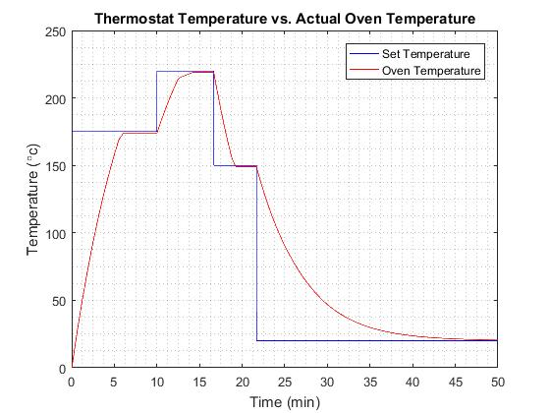  
Figure 1:Desired temperature compared to actual temperature

Figure 1 demonstrates the performance of the fuzzy logic controller. The red line is the actual oven temperature, and the blue line is the desired temperature. The actual temperature never actually reaches the set temperature but is within one degree, which is insignificant. In figure 2 below a zoomed in view from 6 to 10 minutes is shown. Figure 2 better shows the offset from the desired temperature and shows that the actual temperature. This offset is likely due to the fact that the range for zero error in temperature is not 0. The actual temperature appears to have an overshoot above 174 degrees and then oscillates (noisily) around 174 degrees. This behavior is the same at all desired temperatures.

Figure 3 just shows the error between the desired and actual temperature from figure 1. Sharp changes in slope show changes in the voltage to the heater or the fan. This is caused by the oversimplification of the model of the heater, fan, and heat transfer equations. Though for he final desired temperature the curve appears smoother, possibly caused by the cooling process having a better model than heating.

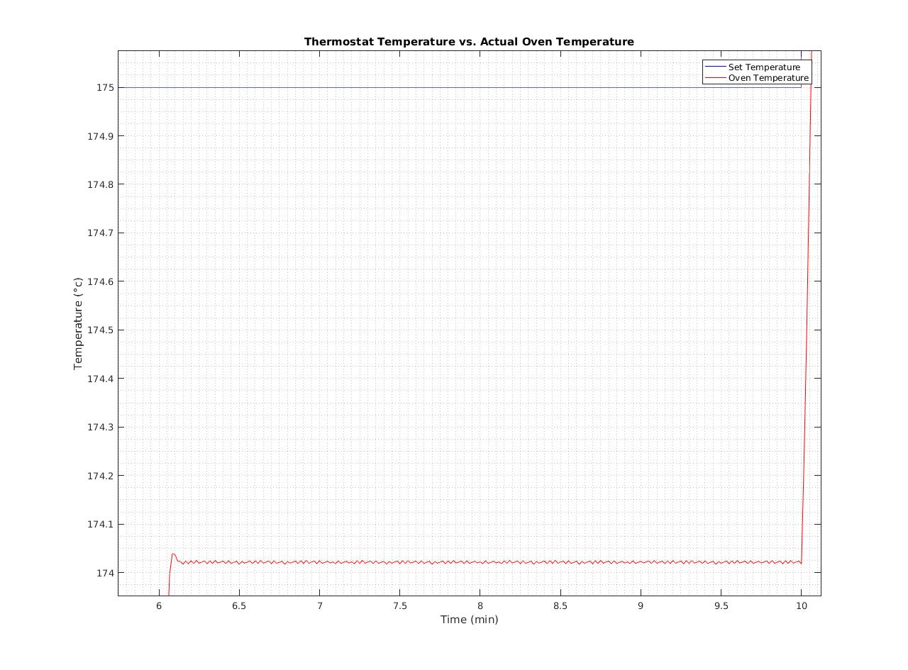  
Figure 2: Actual temperature compared to desired temperature from 6 to 10 minutes

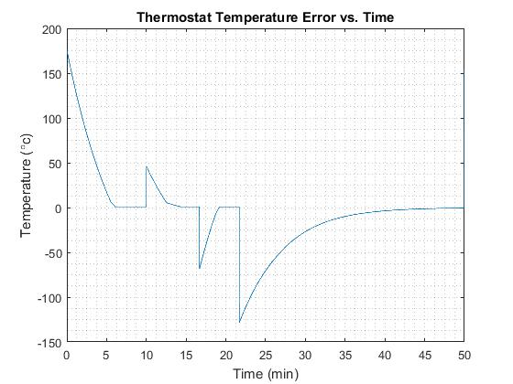  
Figure 3: Overall temperature error

## Conclusions and Recommendations

It is possible to use fuzzy logic as a temperature controller, however, it may not stand up to a PID controller. While the comparison was not investigated, it is possible that a PID controller may provide the same or better results, and with potentially less set up time or complexity. Should any further work be done on this project, that would be something to investigate. Even if PID control were to be investigated, the biggest recommendation to improve this project would be more thorough modeling of physical processes involved. Other potential improvements include, investigating different membership functions to find potentially better ones, and perhaps investigate the impact of different defuzzification methods.

## References

Perhinschi, Mario. “Chapter 03: Fuzzy Logic Part 1”. West Virginia University. Department of Mechanical and Aerospace Engineering. 2017.

Perhinschi, Mario. “Chapter 03: Fuzzy Logic Part 2”. West Virginia University. Department of Mechanical and Aerospace Engineering. 2017.

Perhinschi, Mario. “Chapter 03: Fuzzy Logic Part 3”. West Virginia University. Department of Mechanical and Aerospace Engineering. 2017.